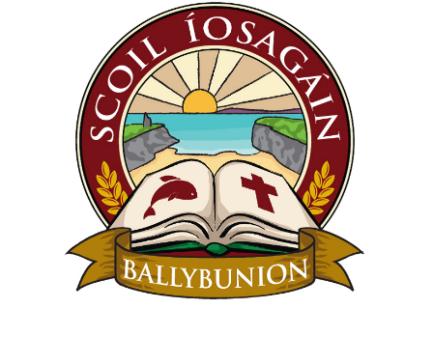
Scoil Íosagáin Ballybunion
ANNUAL ADMISSION NOTICE
in respect of admissions to the 2024/25 school year

Admission Policy and Application Form
A copy of the school’s Admission Policy and the Application Form for Admission for the 2025/26 is available as follows: –
To download at: www.ballybunionprimary.ie
On request: By emailing office@ballybunionprimary.ie or writing to: Scoil Íosagáin, Church Road, Ballybunion, Co. Kerry, V31 F208 or physically by calling to the office Monday to Friday 9.am to 2.30pm

PART 1 - Admissions to the 2025/26 school year

Application and Decision Dates for admission to 2025/26
The following are the dates applicable for admission to Junior Infants

The school will commence accepting applications for admission on | October 1st 2024
The school shall cease accepting applications for admission on | January 31st 2025
The date by which applicants will be notified of the decision on their application is | February 21st 2025
The period within which applicants must confirm acceptance of an offer of admission is | 10 days
*Failure to accept an offer within the prescribed period above may result in the offer being withdrawn

Note: the school will consider and issue decisions on late applications in accordance with the school’s admission policy.

Special Class Application and Decision Dates for admission to Scoil Íosagáin Ballybunion
The following are the dates applicable for admission to the school’s Special Class which caters for children with ASD-
The school will commence accepting applications for admission to the special class on | October 1st 2024
The school shall cease accepting applications for admission to the special class on | January 31st 2025
The date by which applicants will be notified of the decision on their application for admission to the special class is | February 21st 2025
The period within which applicants must confirm acceptance of an offer of admission is | 10 days
*Failure to accept an offer within the prescribed period above may result in the offer being withdrawn

Number of places being made available in 2025/26

The number of places being made available in junior infants is | 26
The number of residential places is (boarding schools only) | Not applicable
The number of non-residential places is (boarding schools only) | Not applicable
The number of places being made available in the special class* catering for children with ASD is | (to reach our maximum number of 12 places)

(*Note: If school has a number of classes that cater for different categories of SEN, details of the numbers of places for each SEN class must be provided)

